# **PYTHON USE CASE PROJECT**

Use Case #1

Task Name: EMAIL SLICING

Definition: An email-slicer is a handy application for separating an email address ’s username and

domain name. It is a simple tool where the email address is provided as an input and as an output, the application returns the username and the domain of the email address given. It makes use of the slicing operations of Python. The first portion of all e-mail addresses, the part before the @ symbol, contains the alias, user, group, or department of a company. Next the @ is a divider in the e-mail address. It’s required for all SMTP e-mail addresses.

Python libraries installed: tkinter – Tkinter is the de facto way in python to create Graphical User interfaces (GUIs) and is included in all standard Python distributions. It provides various controls, such as buttons, labels and text boxes used in a GUI application.

**Code:** email slicer.txt

**Usage:**

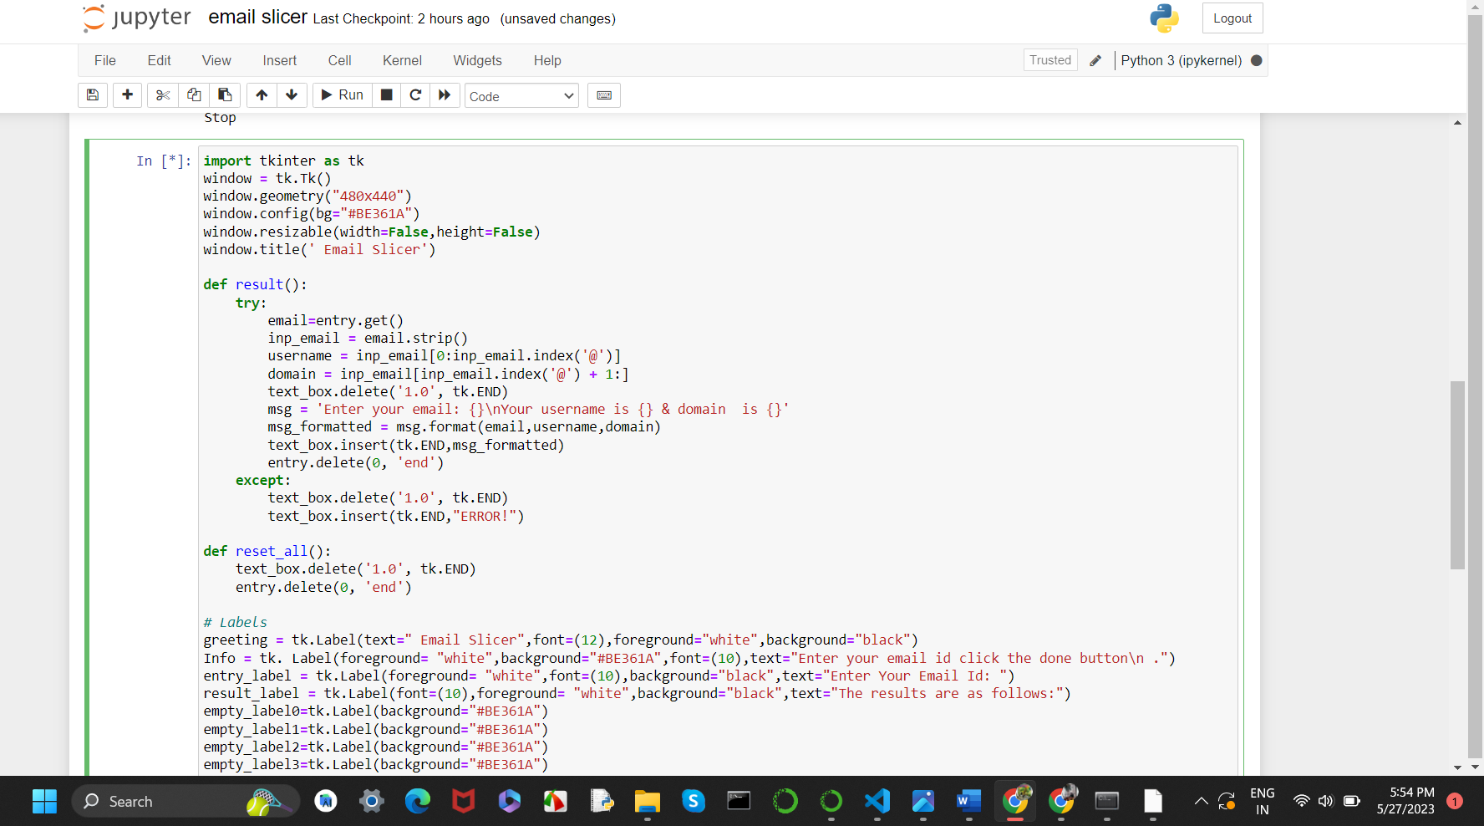

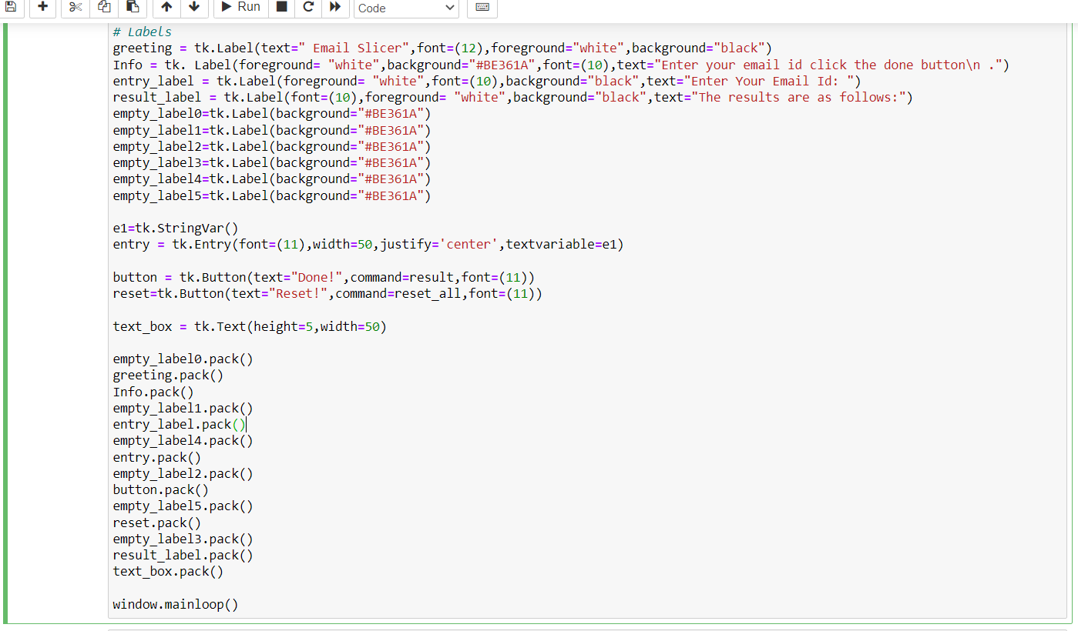

End Result:

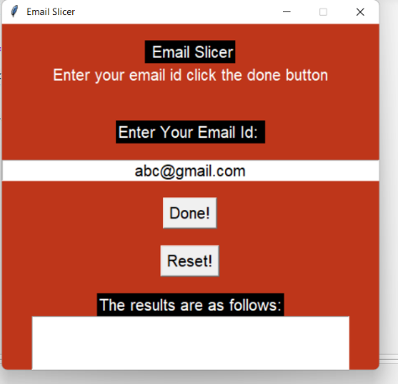

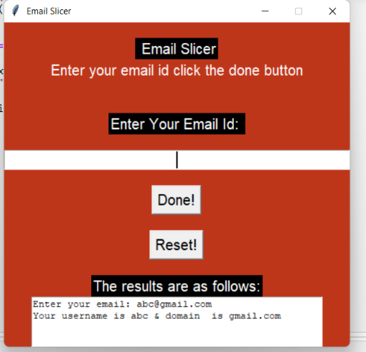

**Use Case #2**

# Task name: CONVERSION OF SPEECH TO TEXT

# Definition: Speech to text is a speech recognition software that enables the recognition and translation of spoken language into text through computational linguistics. It is also known as speech recognition or computer speech recognition. It can offer more convenient or alternative ways for end users to interact with application and devices. Instead of typing words on a keyboard or using their hands for touch screen interactions. Speech- to -text technology allows users to operate applications and devices by voice and through dictation.

Python libraries Installed: Speech Recognition – It is used to convert the spoken words into text, make a query or give a reply. It is a machine’s ability to listen to spoken words and identify them.



PyAudio – It is a library that provides that provides access to audio devices and allows developers to record and play audio.



Code: speech to text.txt

Usage:

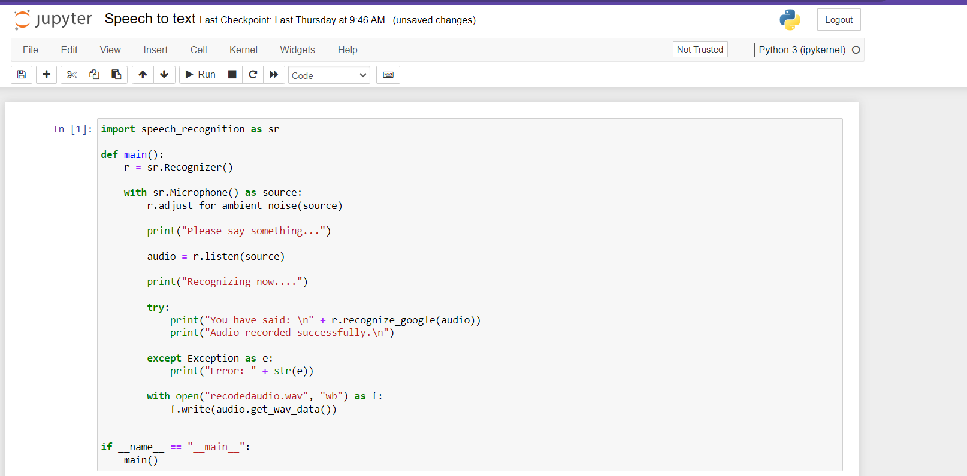

End Result:

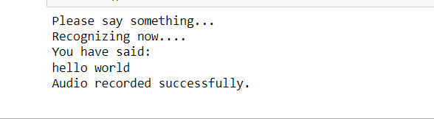

Use Case #3

Tasks Name: **Countdown Timer**

**Definition:** A countdown timer is a virtual clock on a landing page that counts down from a certain number or date to indicate the beginning or end of an event or offer. The user manually sets the countdown timer to indicate the amount of time that needs to be counted down and turns it on. Track time directly in the app, without forcing users to navigate to another time- tracking device on their device.

Python library Installed: **Time** – Python’s time library contains a predefined sleep () function. The “duration” for which we want to delay the execution is passed as an argument to the sleep () function in seconds.



**Datetime**- It is used to manipulate data and time object data



Code: countdown timer.txt

Usage:

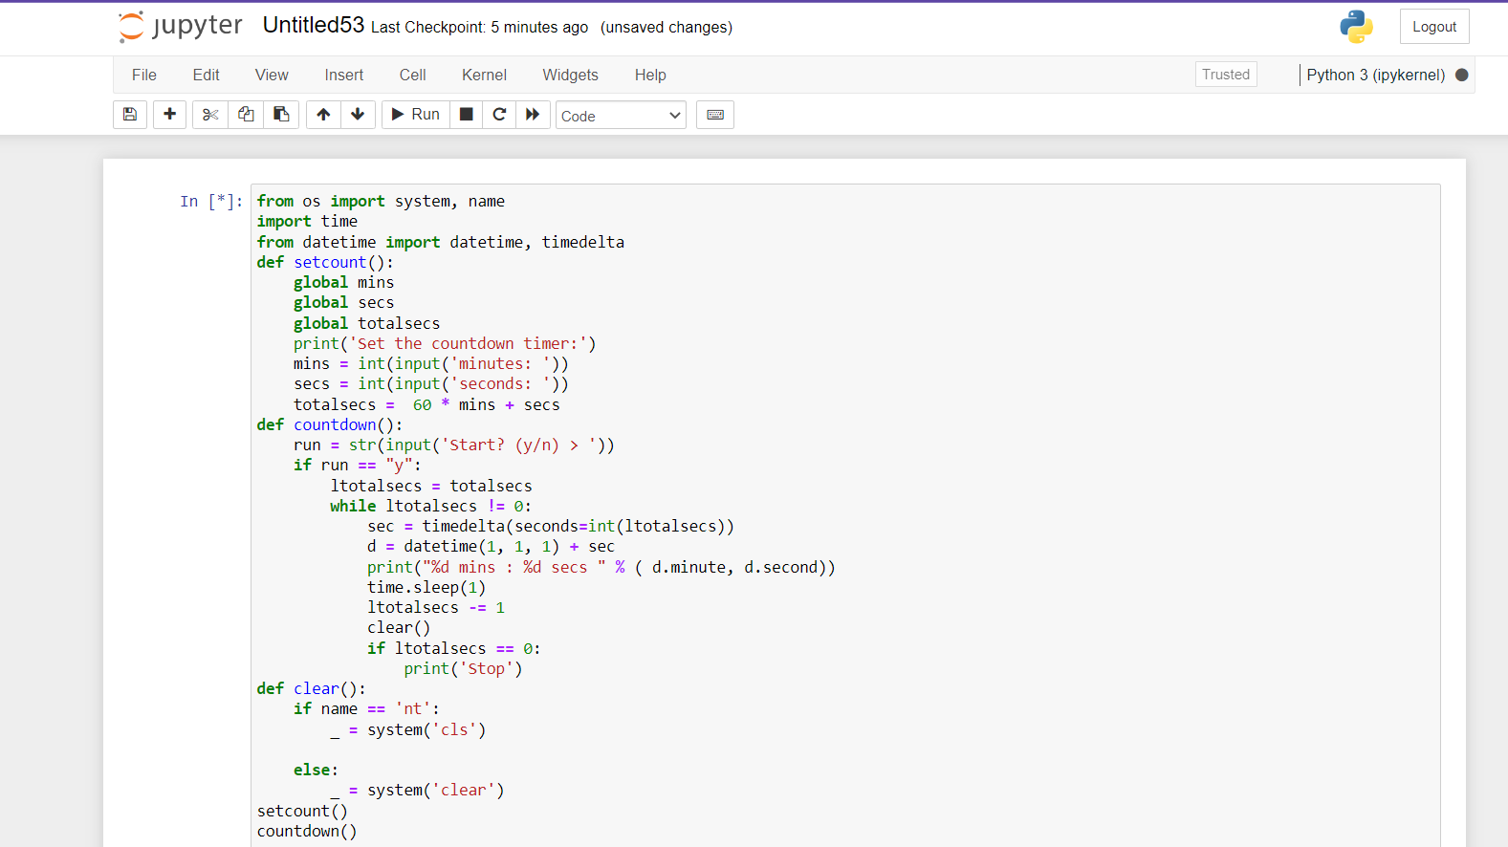

End result:

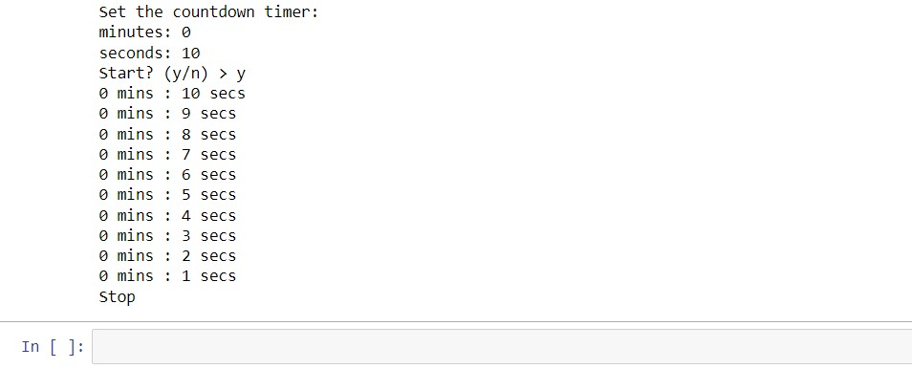

**Use Case #4**

**Task Name: Google image downloader**

**Definition:** Google images downloaderis an useful online software help you type url and download the images from webpage or url. It downloads all the images from url and save into a zip file that will automatically downloaded after completion of process in the active tab. This image download and image extractor tool supports almost all the websites, the only need is to paste the url in the respective place.

Python library installed: requests – It enables you to send HTTP/1.1 requests and include headers, form data, multipart files, and parameters using basic python dictionaries



google_ images_ download-It is used to download tons of images from google.



Code: google images.txt

Usage:

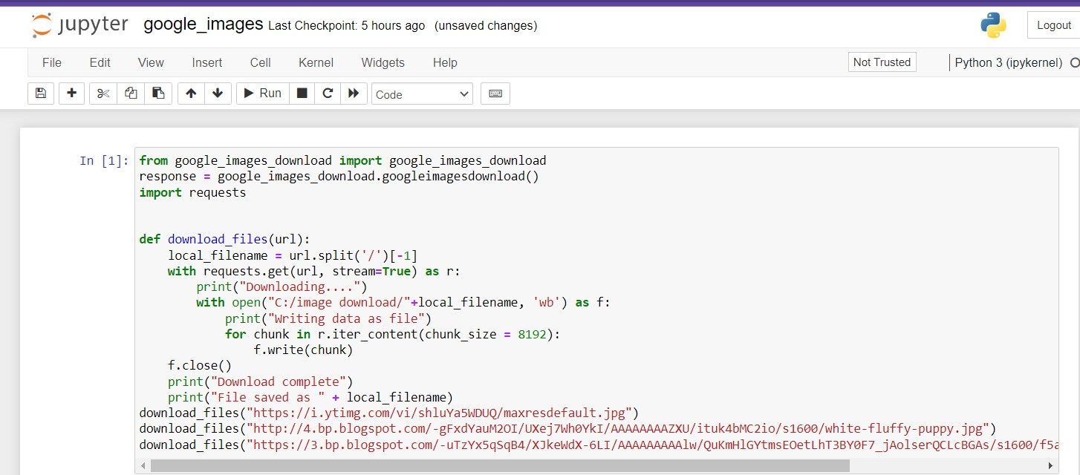

End Result:

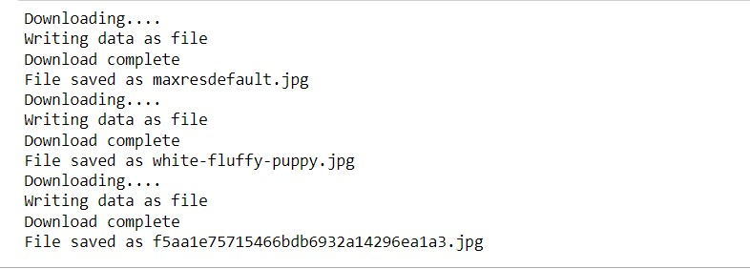

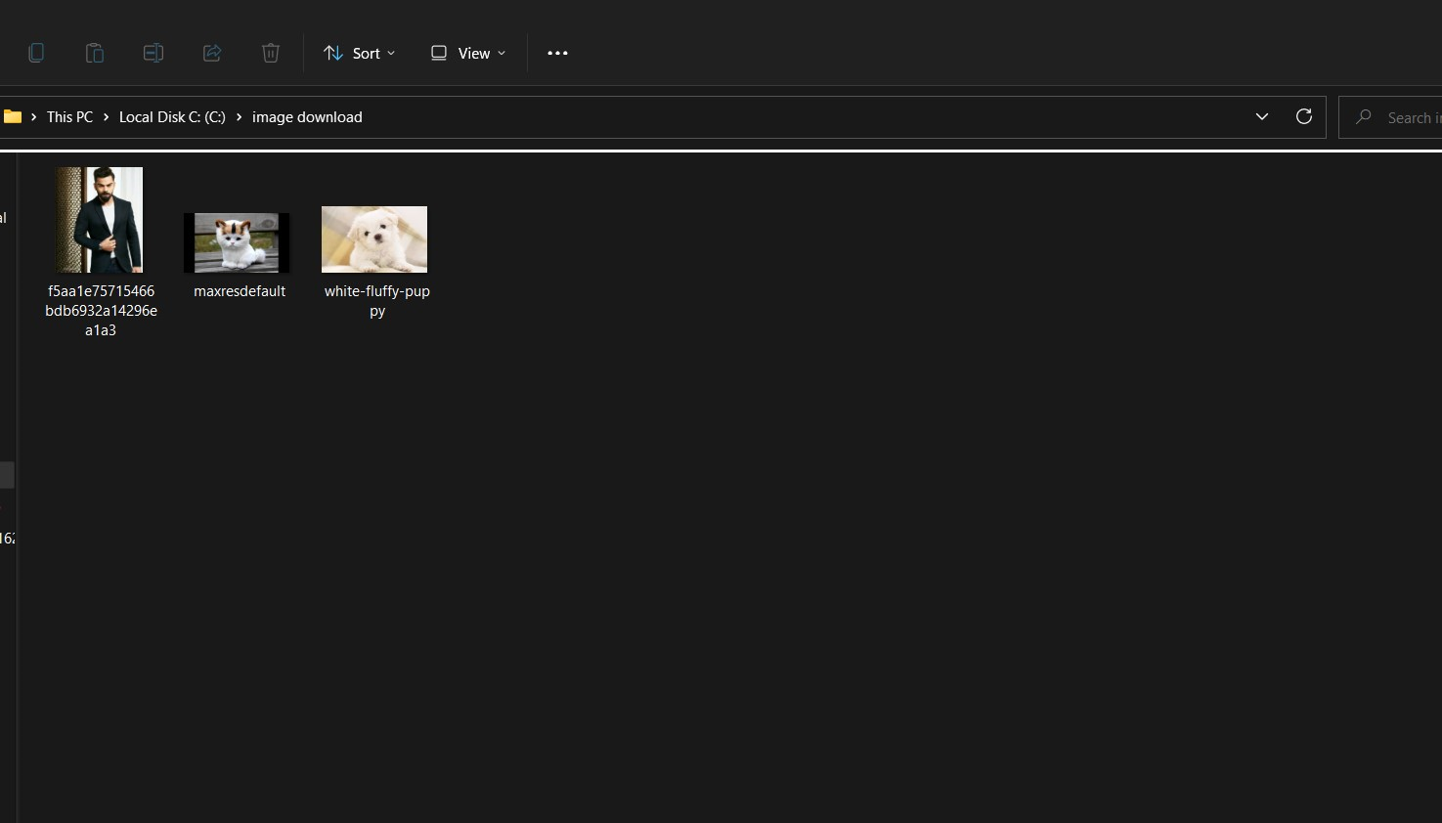

**Use Case #5**

Task Name:Website Blocker

Definition: It is used to block some certain websites which can distract the user interface during the specified amount of time. In this, we will block the access to the list of some particular websites during the working hours so that the user can only access those websites during the free time only.

Python libraries used:tkinter- tkinter is the de facto way in python to create Graphical User interfaces (GUIs) and is included in all standard Python distributions. It provides various controls, such as buttons, labels and text boxes used in a GUI application.

Code: [Web blocker.txt](https://d.docs.live.net/fcb884f54f35f4e6/Desktop/Web%20blocker.txt)

Usage:

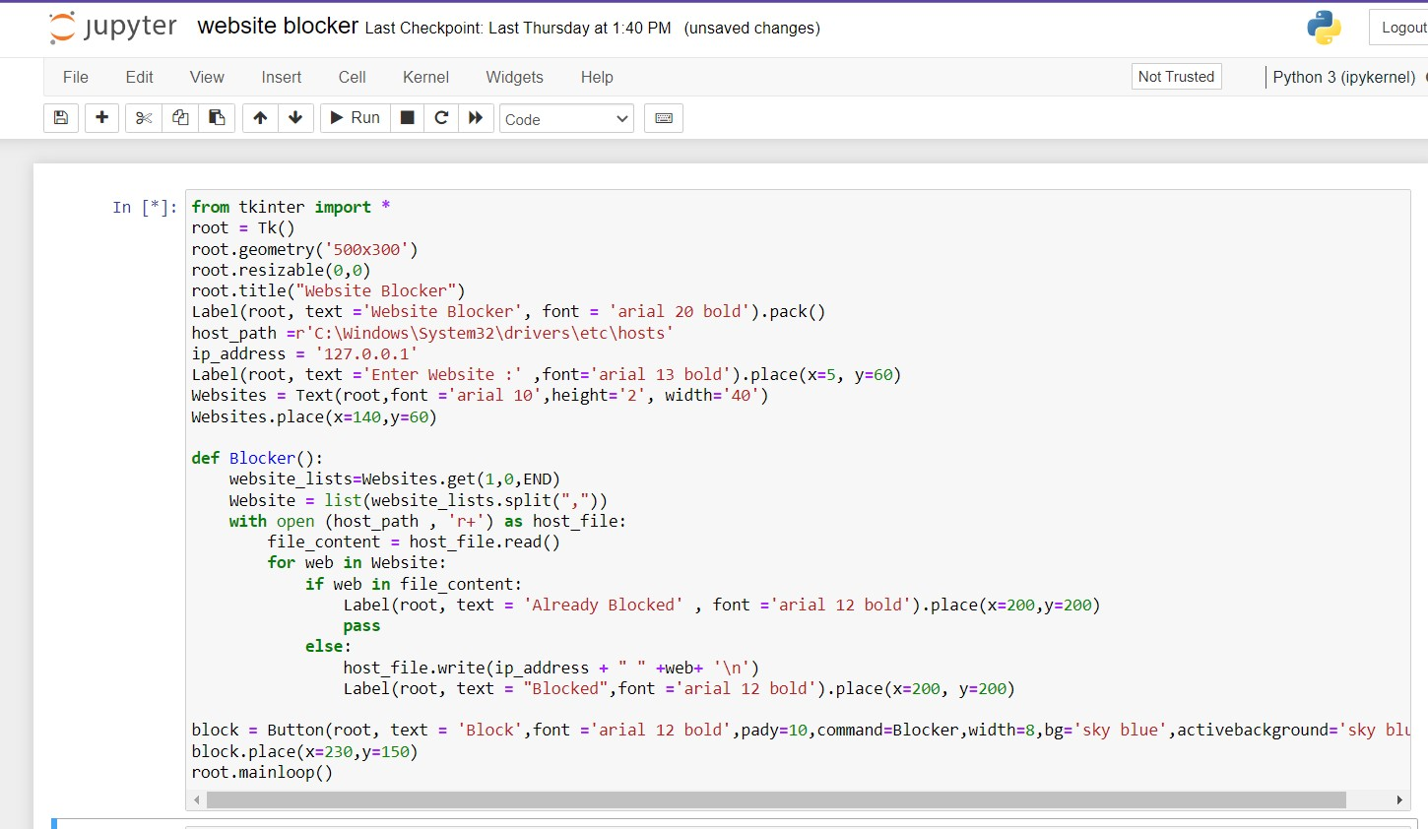

End Result:

